Description

* The carbon has a partial positive charge (due to electronegative oxygen pulling electrons away) and is therefore electrophilic, making it a good target for nucleophile
* Synthesizing aldehyde
  + Use PCC
* Synthesizing ketone (already the most oxidized form for secondary carbon)
  + Use dichromate, chromium trioxide, or PCC

Hydration

* In the presence of water, aldehydes and ketones can react to form **geminal diols**

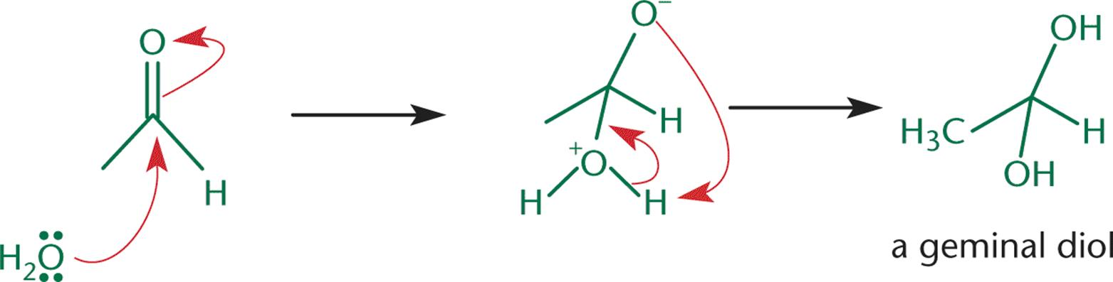

Acetals and Hemiacetals

* Aldehyde + alcohol → hemiacetal
* Hemiacetal + alcohol → acetal
* Ketone + alcohol → hemiketal
* Hemiketal + alcohol → ketal

Things to take note:

* Each of the above reactions must be in **equivalent** amounts.
  + If alcohol is present in **excess**, then reaction will proceed all the way.
  + For example, aldehyde → hemiacetal → acetal
* Hemiacetals and hemiketals are also short-lived
  + This is because the -OH group will rapidly be protonated in acidic conditions and is lost as water
  + This leaves behind a carbocation that is very susceptible to attack by an alcohol

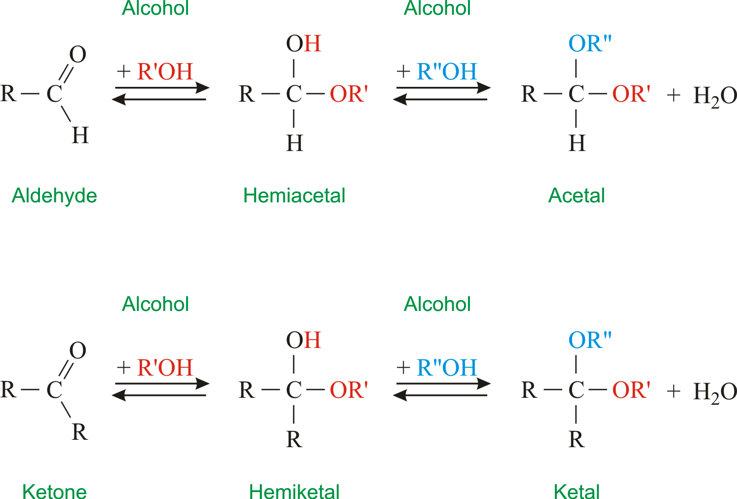

Imines and Enamines

* Nitrogen and nitrogen derivatives react with carbonyls to form **imines**, oximines, hydrazones, and semicarbazones

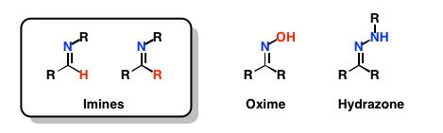

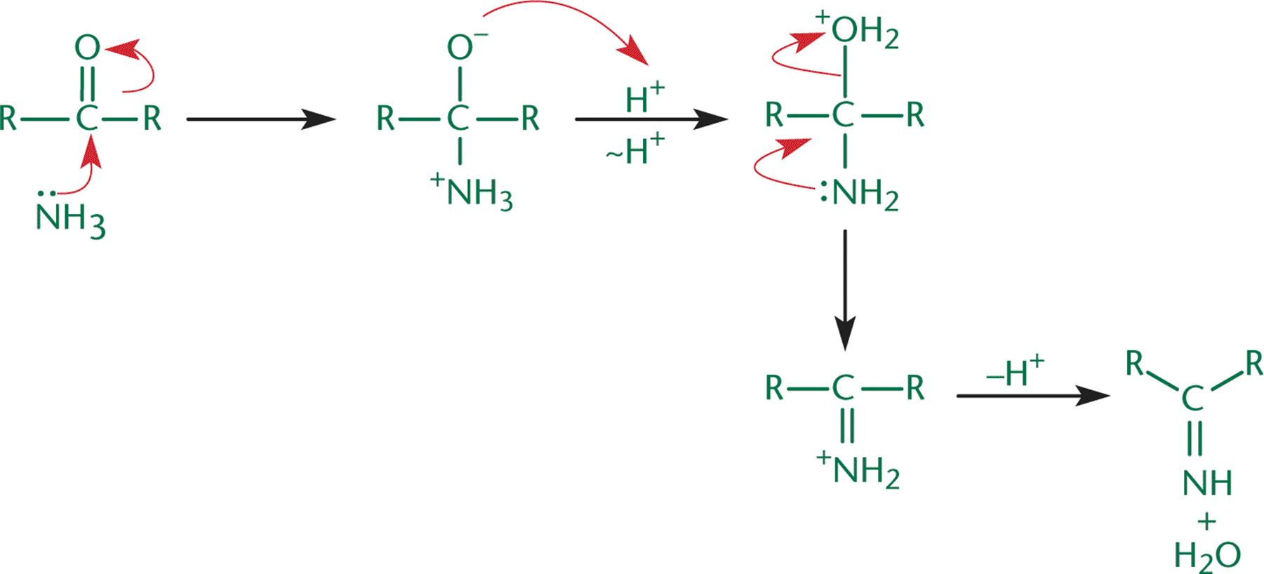

(Imine Formation)

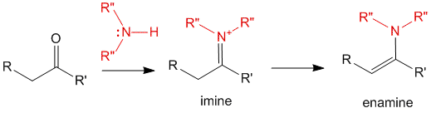

(Imine can undergo tautomerization to form enamine)

Cyanohydrin

* Hydrogen cyanide reacts with carbonyls to form cyanohydrins
  + HCN- can attack the carbonyl carbon

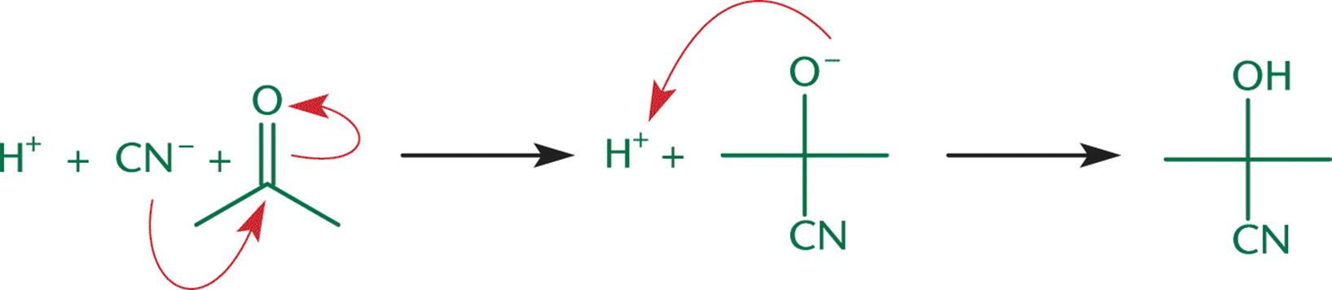

Oxidation-Reduction Reactions

* Aldehydes
  + Can be oxidized to **carboxylic acids** using **KMnO4, CrO3, Ag2O, H2O2,** etc
  + Can be reduced to **primary alcohols** using hydride reagents **(LiAlH4, NaBH4)**
* Ketones
  + Cannot be further oxidized
  + Can be reduced to **secondary alcohols** using hydride reagents **(LiAlH4, NaBH4)**